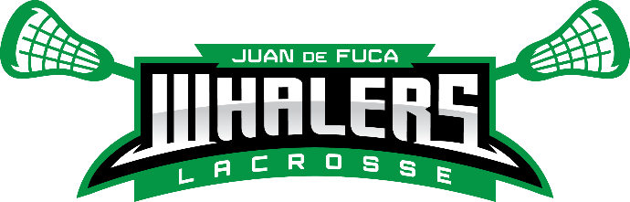
2025 Field Lacrosse Coaches Application - Please submit to Curt.Morwick@jdflacrosse.com and/or Blake.Anderson@jdflacrosse.com
on or before August 8, 2025

Applicant Information
Last Name |  |  |  |  |  |  | First |  |  |  |  |  | M.I. |  | Date
Street Address |  |  |  |  |  |  |  |  |  |  |  |  | Apartment/Unit #
City |  |  |  |  |  |  | Prov |  |  |  |  |  | PC
Phone |  |  |  |  |  |  | E-mail
Cell # |  |  |  |  | NCCP Number |  |  |  |  |  |  | Date of Criminal Record Check
Division applying for
Do you have son/daughter in this division at JDF? |  |  |  | YES |  | NO |  | Are you willing to coach whichever Tier your player is placed into? |  |  |  |  |  |  | YES |  | NO
Child’s name:

Coaching History –

- All coaches must meet BCLA Coaching requirements by end of September 2025
- A criminal record check must be done in the last 3 years and provided to the JDF Association Risk Manager prior to being on the floor/field for any games or practices
- All coaches must display strong fair play principals
- All coaches must be a member of the JDF Association in good standing

